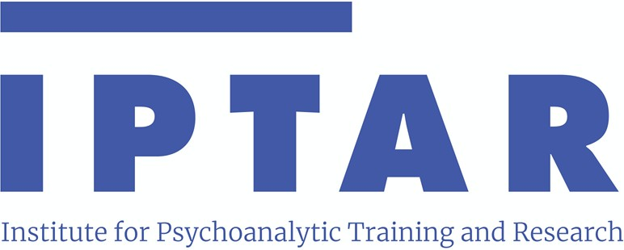

**Respecialization Training Program**

Course Curriculum

The theoretical component of the Respecialization Program consists of mandatory course work (four eight-week quarters, two classes each quarter, on Wednesday evenings) and optional classes in the Child and Adolescent Program (CAP).

During these two years candidates learn in class the basics of psychopathology, technique and diagnosis from a Freudian and post-Freudian approach and its challenges with new clinical societal realities.

# FIRST YEAR

* Clinical Seminar Part I and II (First Semester)
* Psychopathology Part I and Part II
* Introduction to Psychoanalytic Psychotherapy
* Clinical Seminar Part III and IV (Second Semester)
* Introduction to the Treatment of the More Disturbed Patient

# SECOND YEAR

* Clinical Seminar (Part I and II)
* Introduction to Classical Technique Part I and II First Semester
* Clinical Seminar Part III and IV
* Clinical Aspects of Diversity Part I and II Second Semester